Lidingöloppet 2019
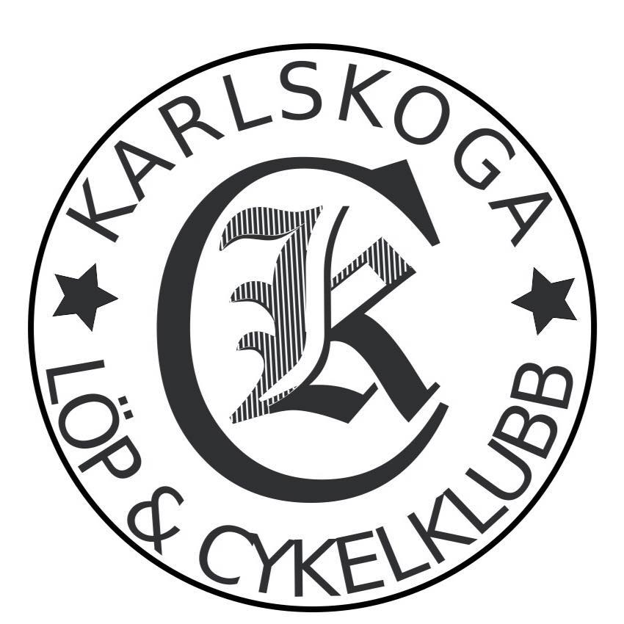

2018-09-28

Resultat Karlskoga LCK:

30 km:

3593 (M) (4146 totalt) Mikael Strussenfelt -62 2:49.38
3767 (M) (4376 totalt) Christer Tiger -68 2:51.07

Segertid: 1:37:55

