Frankfurt Marathon 2017

2017-10-29

Resultat Karlskoga LCK:

215 (M40) – 1128 (M) Torbjörn Björn -74 3:03.31
730 (M30) – 4951 (M) Victor Drevenstam -84 3:53.33

Segertid: 2:05.50

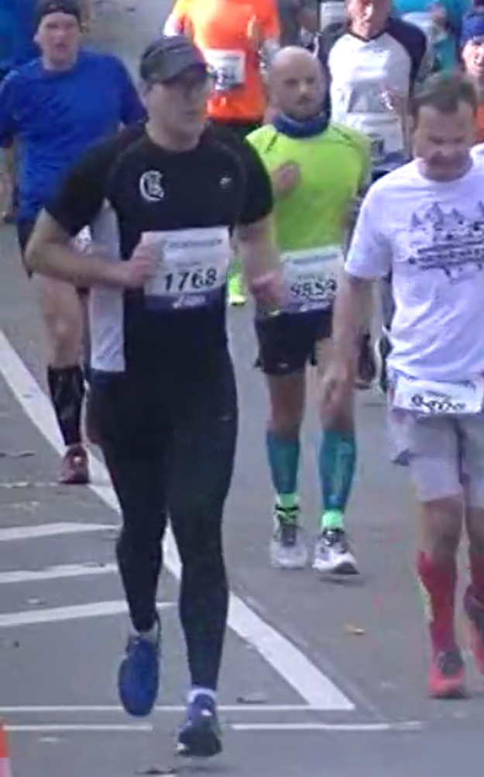
Tobbe Victor

